Maps activity
For these problems you can cut out the map and stick it in your books. Draw on the map the routes you are taking with a ruler, detailing the measurements. You have a car that travels at an average speed of 70 mph on the motorway and 30mph on all other roads. You also have a boat that can travel at 8knots and you can walk at 6km/h. Trains travel at an average of 40mph. All scales are shown on the top of the maps.

Task 1

1:50000
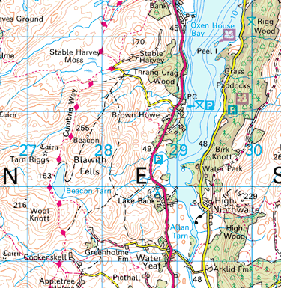
You need to get from Lake Bank to Rigg Wood. Identify all possible methods of travel and find the shortest possible distance for each. Then calculate the time each method would take.
Make sure you show all calculations and organise your work appropriately.

Task 2
1:250000
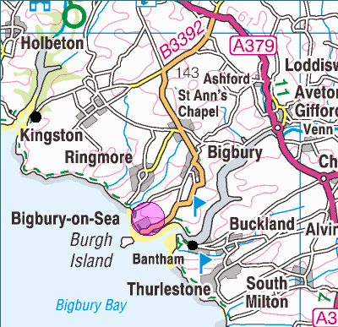
You need to get from Kingston to Bantham (indicated with black dots). Identify all possible methods of travel and find the shortest possible distance for each. Then calculate the time each method would take.

Make sure you show all calculations and organise your work appropriately.

Task 3
1:100000
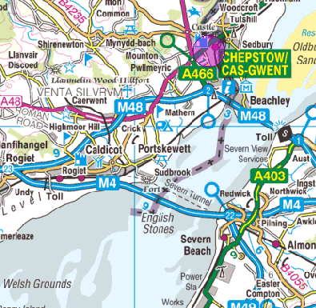
Task 3: You need to get from Almondsbury station to Chepstow. Identify all possible methods of travel and find the shortest possible distance for each. Then calculate the time each method would take.

Make sure you show all calculations and organise your work appropriately.

